**Sign-Up Form**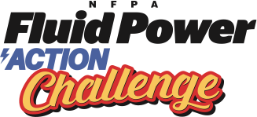

**The NFPA Fluid Power Action Challenge is a competition that challenges middle and high school students to solve an engineering problem using fluid power technology.**

Complete and return this form to reserve your spot at the following event:

<insert location>

<insert address>

<insert address>

<insert city, state>

**Workshop day:** <insert date & time>

**Challenge day:** <insert date & time>

Participating schools provide:

* A team, or multiple teams, of four students (mixed teams are recommended)
* A registration fee of <insert your registration amount> per team
* Transportation for your team to the pre-competition workshop and full day competition

**Students** acquire numerous skills throughout the competition and are exposed to careers that involve fluid power and other technologies. **Teachers** are given support and resources for science and technology curriculum.

I would like to participate in the **NFPA Fluid Power Action Challenge**!

|  |  |
| --- | --- |
| **Teacher’s Name:** | |
| **Name of School:** | |
| **Address:** | |
|  | |
| **# of Teams:** | **Telephone #**: |
| **E-mail:** |  |

**Return this form with check made payable to:** <insert your organization name>

<insert address>

<insert address>

**Return by:** <insert deadline date>