**Sample Email**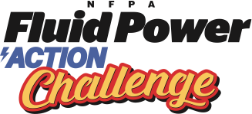

To Teachers Once Teams are Signed Up

*Coordinators should customize*

**Subject Line: NFPA Fluid Power Action Challenge – Student Forms & Team Registration**

Dear Challenge teams,

Thank you for signing up for the NFPA Fluid Power Action Challenge scheduled for <insert date> (Workshop Day) and <insert date> (Challenge Day) at <insert location>.

Attached are four forms for the event:

1. Challenge Agenda / schedule  
2. Rules for Challenge  
3. Team Registration form (one per team)  
4. Student Consent form (one per student)

Please complete and return the Team Registration and Student Consent forms to my attention no later than <insert deadline date>.

Also, you can learn more about the National Fluid Power Association (NFPA) and NFPA Fluid Power Action Challenge on YouTube, Instagram, and LinkedIn.

Please reply with questions or if you require additional information. We look forward to seeing you at the Challenge!