**Sample Email**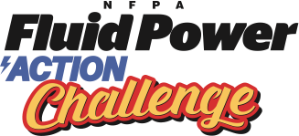

To Local Companies Asking for Support

*Coordinators should customize*

Dear ___________:

I am pleased to announce that <insert your company / school / organization name> is planning to hold an NFPA Fluid Power Action Challenge on the following dates and we would like your sponsorship assistance.

Workshop day: <insert date> Challenge day: <insert date>

**Ask:** We are seeking event sponsors to help offset costs and create a fantastic experience. The attached Sponsorship Flyer Form shares more information. Please complete the Sponsor Form to support the event, learn more, and attend; then, submit the completed form to this email. Additional information follows.

**NFPA Fluid Power Action Challenge:** a skills-based competition for middle and high school students, who work in teams to solve an engineering problem using fluid power (hydraulics and pneumatics). Teams utilize hands-on learning, STEM education, and key skills (problem solving, time management, communication, collaboration, and project management) to compete. You can learn more [here](https://nfpafoundation.org/middle-schools/programs-resources/fluid-power-action-challenge/getting-started/).

**Workshop Day:** teams learn about fluid power and receive their challenge kits (materials & tools). Students then return to the classroom to research, design, and build a fluid power machine prototype to solve the engineering challenge.

**Challenge Day**: teams re-build their fluid power machines with fresh materials and compete on a Challenge Board in a timed competition. Points are earned by moving a weighted cylinder from a starting point to select spots on the board.

This fun and amazing event excites students, introduces fluid power, reinforces STEM education, and builds on key skills that can benefit a skilled workforce in our community. We hope you can sponsor and attend the event.