Understanding Basic Fluid Power Symbols and Schematics

Ernie Parker CFPAI
ErnieParker1@msn.com 952-200-3359


Pumps

Motors

Fixed Displacement

Bidirectional Variable
Displacement

Fixed Displacement
Bidirectional
Unidirectional Pump/Motor
Bidirectional Pump/Motor
Limited rotating Motor

Hose

Connected Not Connected

Reservoir or Tank

Single Acting Cylinder Double Acting Cylinder

Block Port Joint
Gage or Gauge

Free Flow
Adjustable flow control Orifice or
Fixed flow control



Lever 2, 3 Detents

Accumulator and Unloading circuit

To Circuit



Spring Weight Pneumatic

Unloading circuit
Check Valve

Pump

Filter


Hi-Low Pump
Intensifier Proportional Solenoid

Pneumatic
Push Button
Hydraulic
Mechanical

Air Receiver


Adjustable Flow Control with reverse flow check
Pilot
Pilot



2 Way 3 Way 4 Way 4 Way 5 ported Spring Operated
Check Valve
Ball Valve

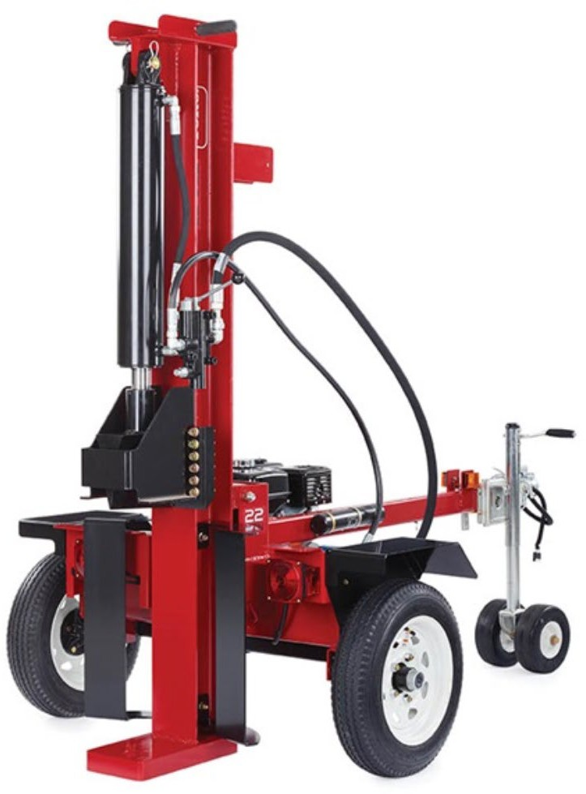


Log Splitter

System specs: 30 GPM @ 3000 PSI Cylinder extends and clamps for 20 minutes
Loss Power: 3 HP at 5% of PC pump if pump continues to run.

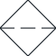
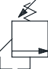
60 HP Electric Motor

Hard start

Add accumulator and resize pump to a 5 GPM and
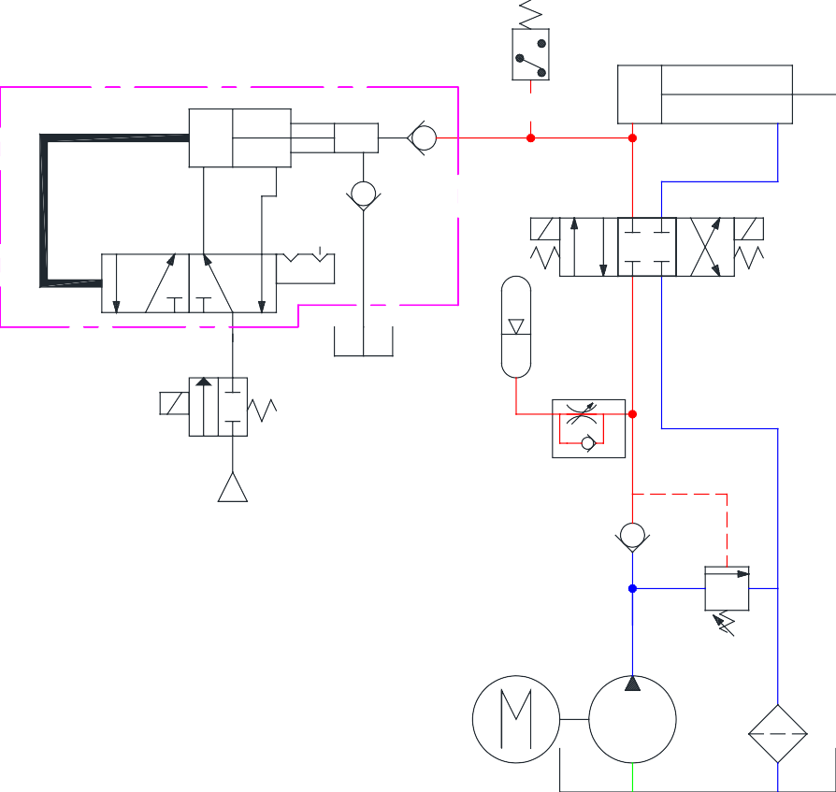
turn off. If the pump turned off
at 1000 PSI, the required power is 3 HP.

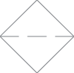


4000#
2" Bore x 3" Stroke
1274 PSI
1-1/2 HP 120 VAC
Neil Smith


?


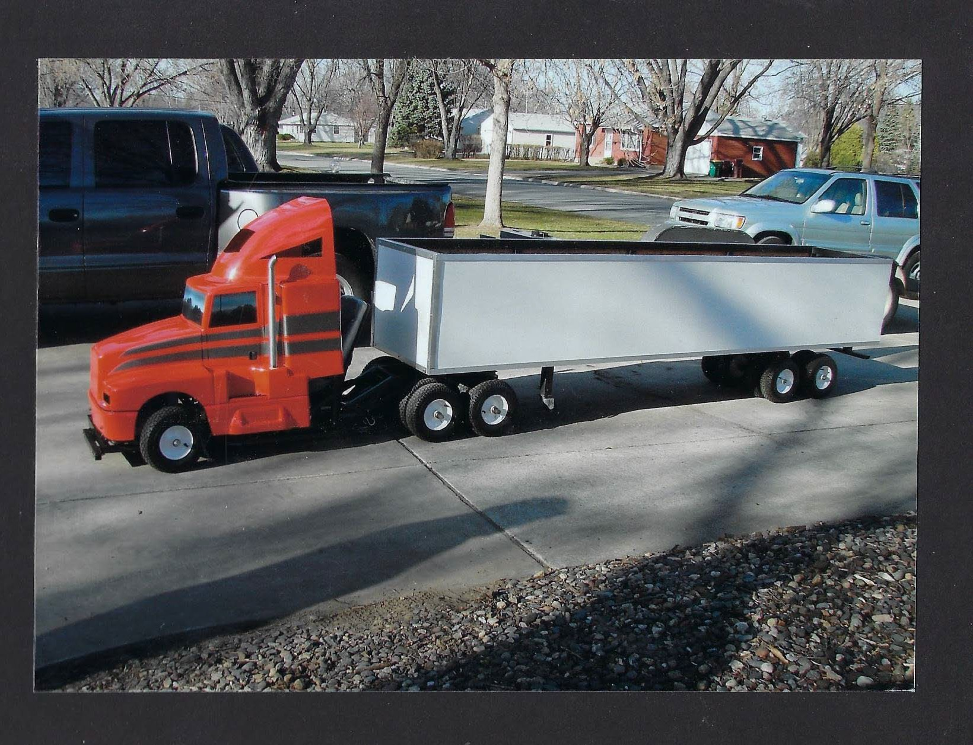

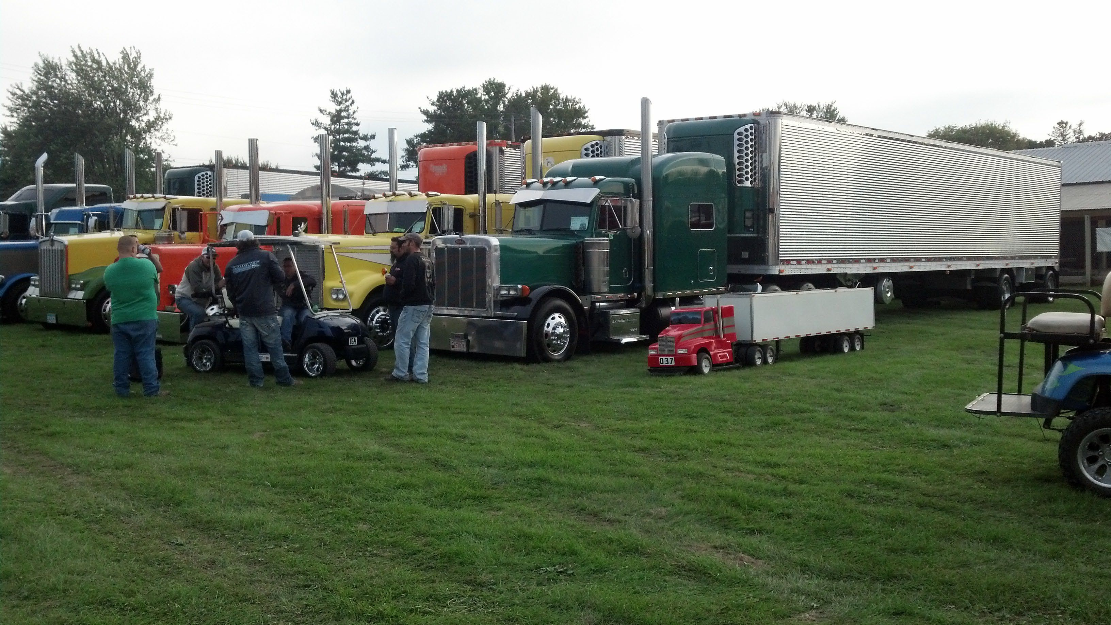
Semi Truck

Loft Door
To Open: Push lever down and then pull up. To Close: Push lever down and back
to center position


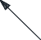















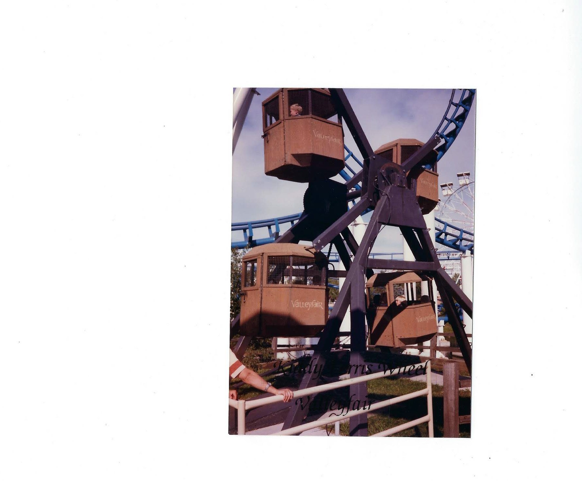


4" x 20" x 3"
Given:
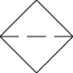
Pump flow is 10 GPM
B
C
A
E
D
M
What size lines should be use if our
flow rate is 5'/sec. inlet and 20'/sec. for pressure and return lines?

A:

B:

C:

D:
Extension

E:
F:

Area = D x D x .7854 A = .32 x GPM / Ft./Sec.

Ft./Sec. = .32 x GPM / Net Area
D = Sq. root of A / .7854

Flow straight through a tee as a run with 155 SUS oil at 30’ per second has a pressure drop 5.45 PSI for an 1” hose
Flow going into the straight of the tee and exiting out the branch of the tee has a delta P of 14.5 PSI
Each tee could cost you up to 3 times the pressure drop as going straight through.

Many manufactures recommend a maximum of 5 inches of mercury ( in. hg). 5.45 PSI is already about 11 in. hg. One elbow can cause heavy cavitation by itself if not properly sized and placed.

Sizing of the Main System
ISO Standard: 16 Ft/Sec for a pressure line This has changed again.
8 Ft/Sec for a return line 4 Ft/Sec for in inlet line

NFPA Standard: 20 Ft/Sec for a pressure and return line
5 Ft/Sec for an inlet line SAE Standard for closed loop: Up to 25 Ft/Sec.
For reason such a cost, flexibility of hoses, cost of components and conductors, payback time, life of components and oil, duty cycle, and many other reasons, I choose the 20/5 feet per second unless otherwise specified. However, it has to be a true number including retracting of cylinders and flow in tubing compared to hoses etc.

NOTE: More important that the velocity of the inlet is the plumbing. No elbows, shut off valves, strainers, etc. within the last 10 diameters of hoses going into the pump. Also flaring the pick up tubing in the reservoir is a big help. If possible, use flange fittings going into the pump for better flow characteristic. Use a hose rather than tubing to and from the pump.
Hoses can take up vibration from the pump and prime mover and also act as an accumulator when pressure rises abruptly and the relief valve and/or pressure compensators haven’t opened yet in the first 15 or 35 milliseconds. This is the most important plumbing in the entire system for performance, controllability, noise, and life of the pump as well as other components.


Proper Inlet Plumbing
Proper plumbing is far more important than appearance.
Stay away from the pump inlet port with any kind of turbulence for the last 10 diameters of the hose feeding the pump.

This means no top reservoir inlet filters drawing oil from the tank, through the filter and a right turn right into the inlet of the pump.
No elbows, strainers, shut off valves, temperature probes, tees or anything but a clean hose of proper size going straight into a flange fitting if possible. If needed use a sweeping elbow. Eliminate any steps that will cause an interruption of laminar flow.

Proper Inlet Plumbing
Flooded inlets from the reservoir are the best
Don’t use pipe for inlet pickups. Use tubing that the end of the tubing is flared. This will fill up much better than a pump submerged under the oil without any plumbing at all. No fitting at all will act somewhat like a sharp edge orifice and vortex and will reduce the inlet flow. A normal bend in the inlet tubing is ok to use. Over sizing the inlet tube is needed, but use a hose from the tank to the pump that is at least 10 diameters long.
Hose should be used to reduce vibration and has a larger ID. Hose should also be used leaving the pump. It acts as a poor man’s accumulator to help absorb pressure spikes until the relief valve or compensator can react.

Reservoir Inlet Design

Minimum oil level needs to be at least 2 diameters above the inlet line
> 5 times the inside diameter of the tubing

5.0
2.0

1.0

4.0

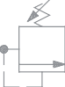

Two Speed Circuit

Crossover valve would have four ports, two in and two out.
Add a crossover relief valve as close to the motors as possible to reduce the shock to the motor shafts.
MOA 17
Adding Crossover Relief Valve
9-28-17
EP
Motors
Power Unit
Hose
Hose
Crossover Reliefs

Parallel/Series Circuit Shown without charge pump and relief valves

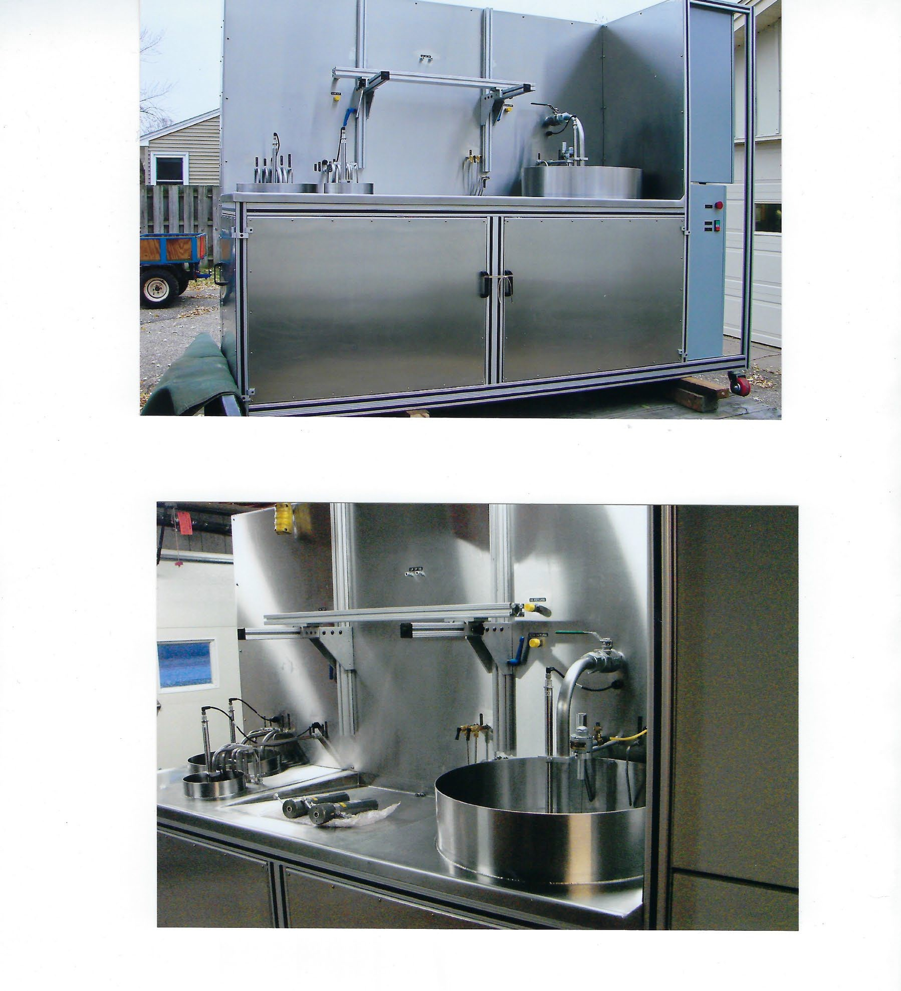

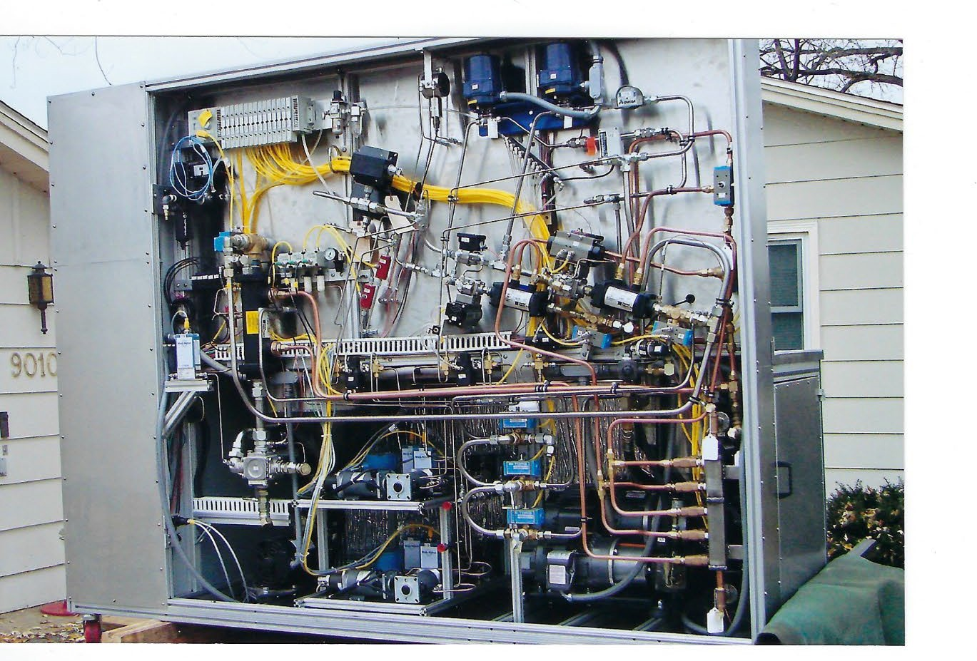


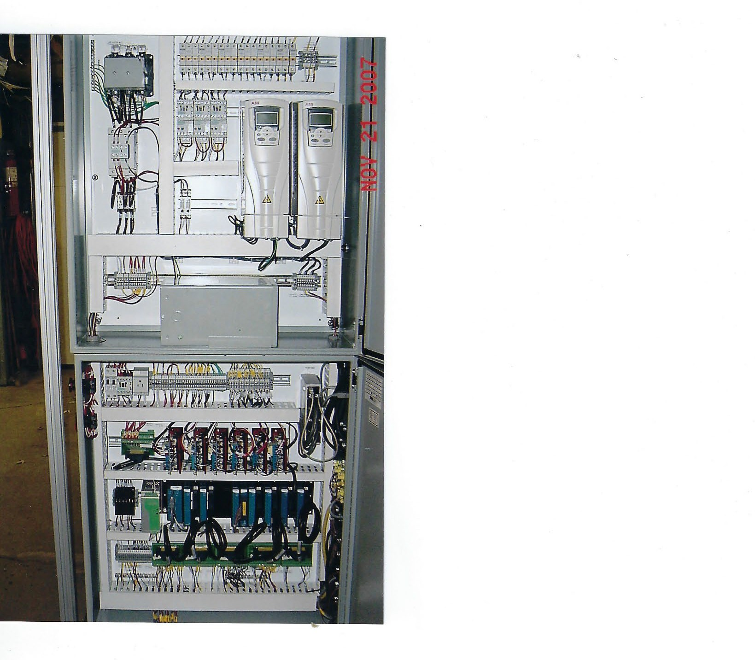

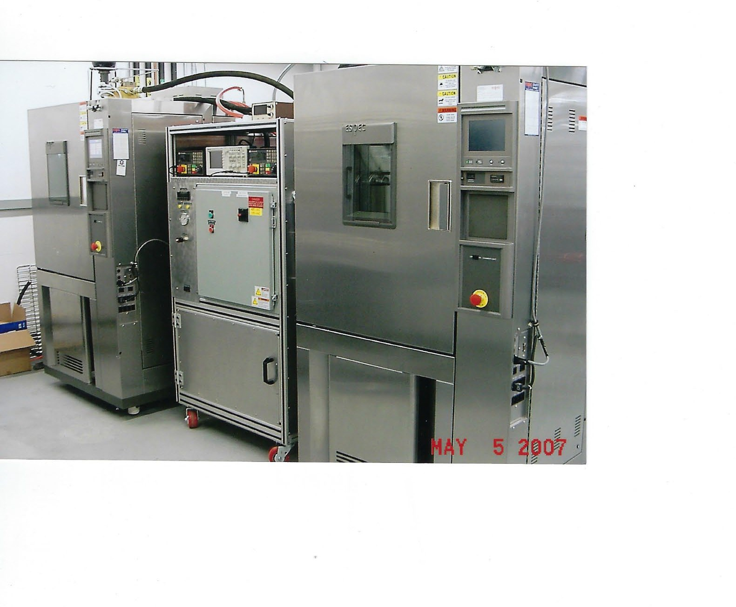

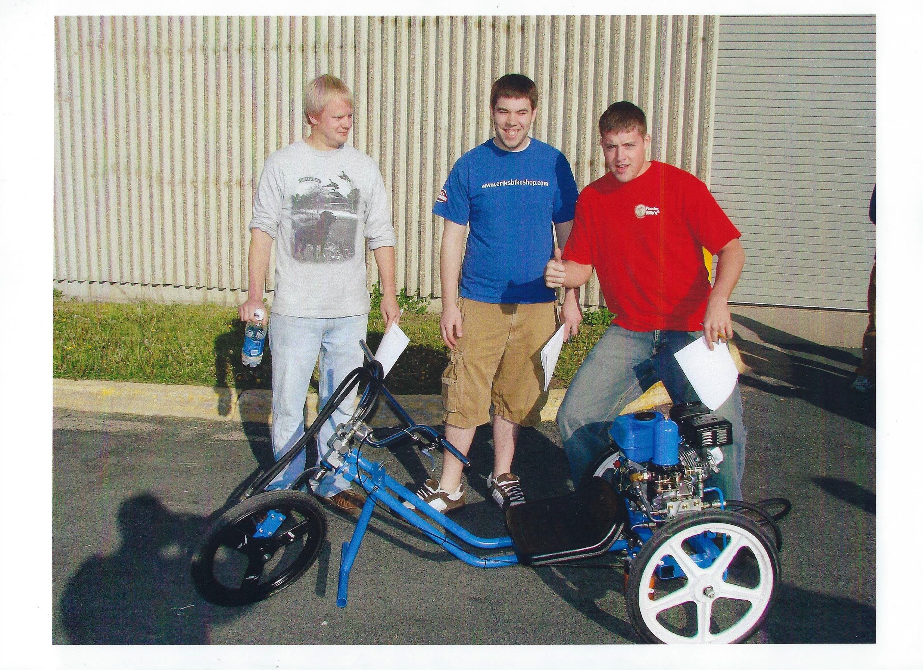
360 MPG

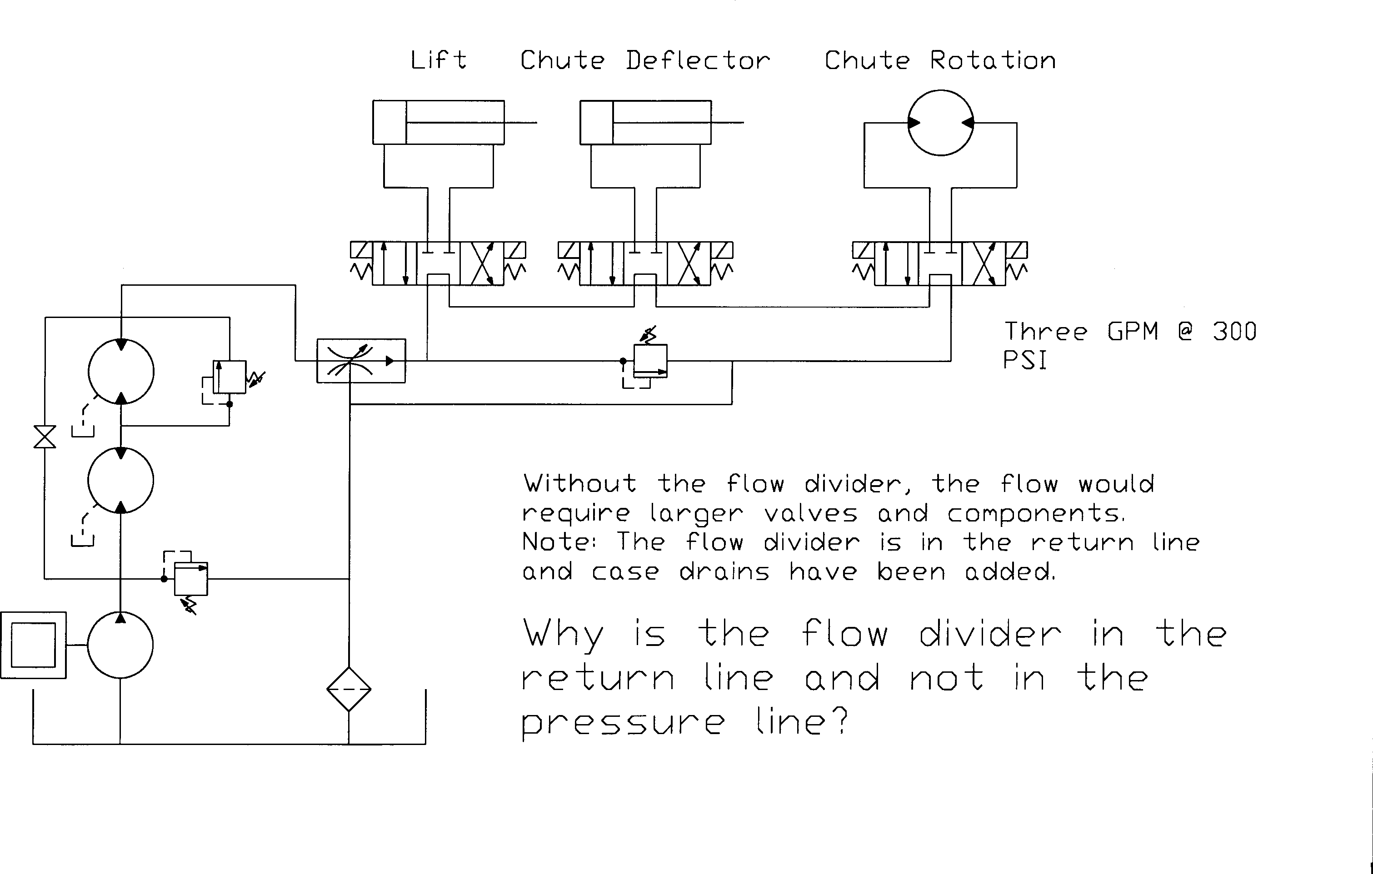

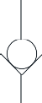
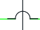
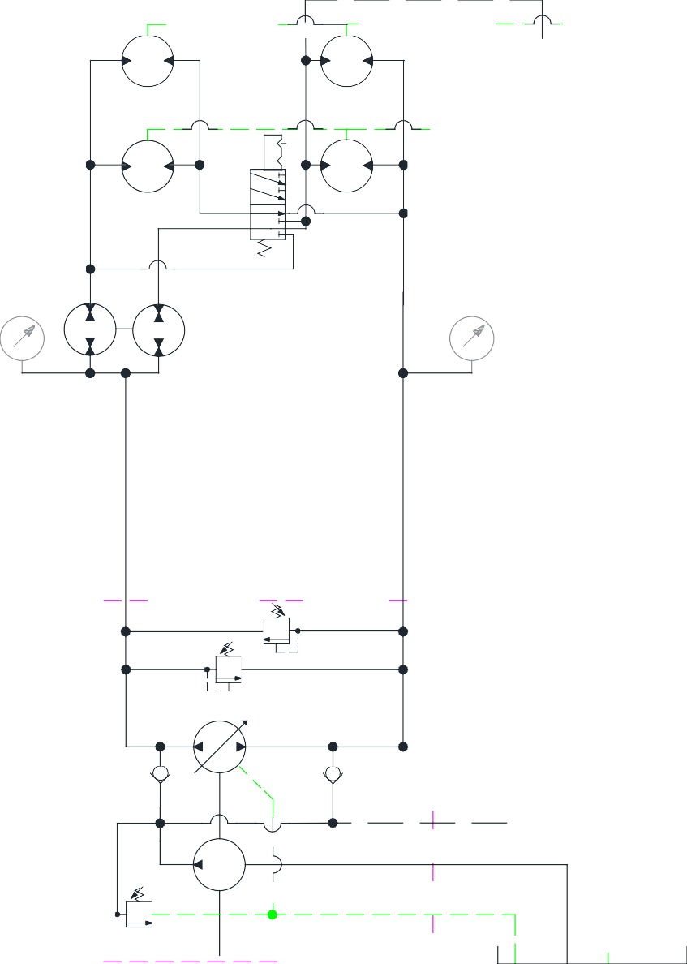
Parallel/Series Circuit with Posi- traction front to back wheels

24
CID

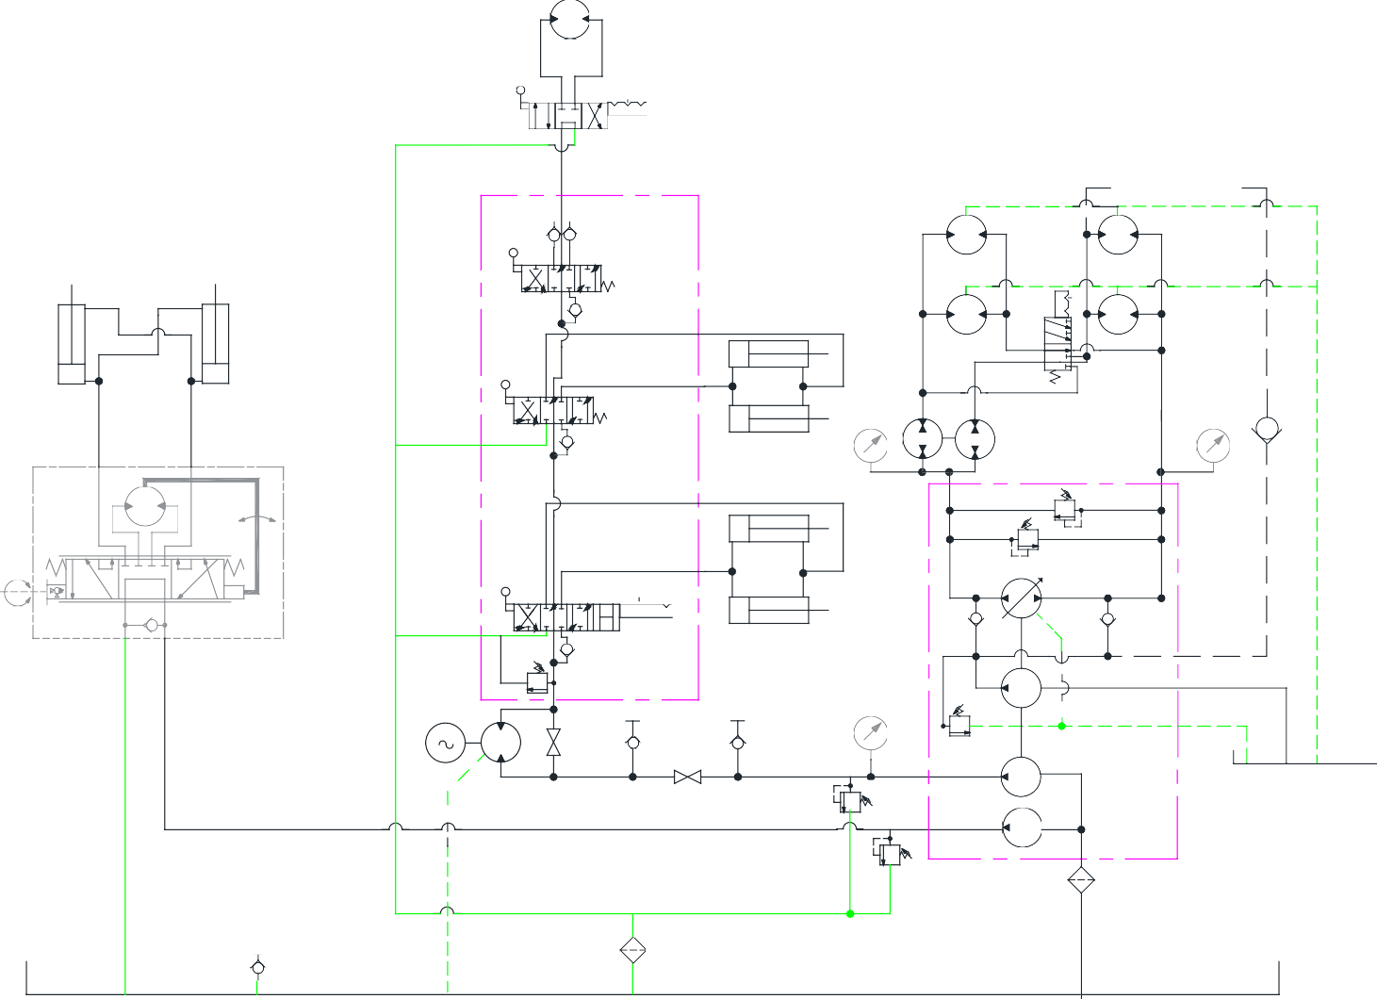
Winch Attachments:

- Stump Grinder
- Post Hole Auger
- Stake Driver
- Leaf Shredder
- Air Blower
- Cement Mixer
- Bucket

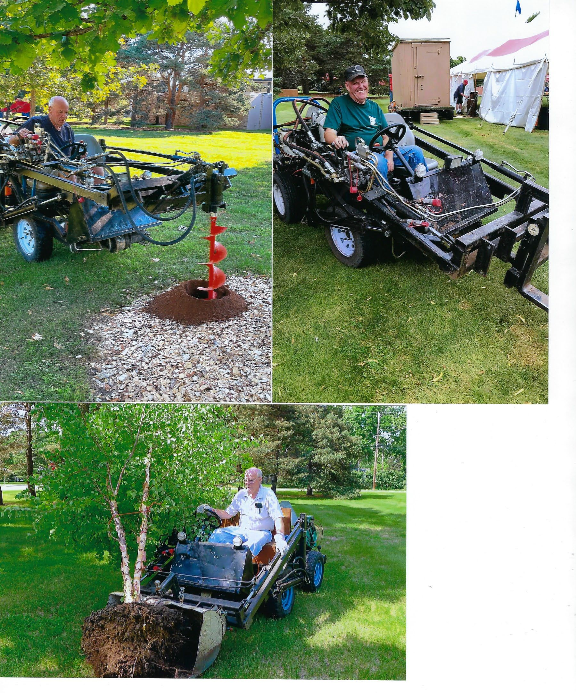
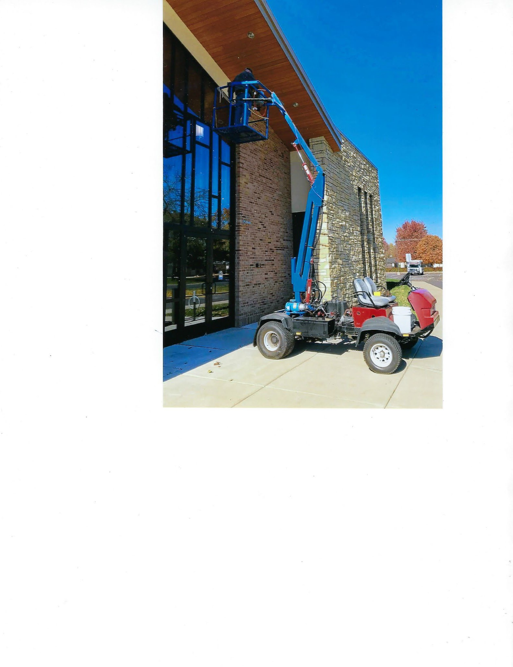





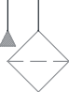
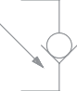
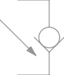
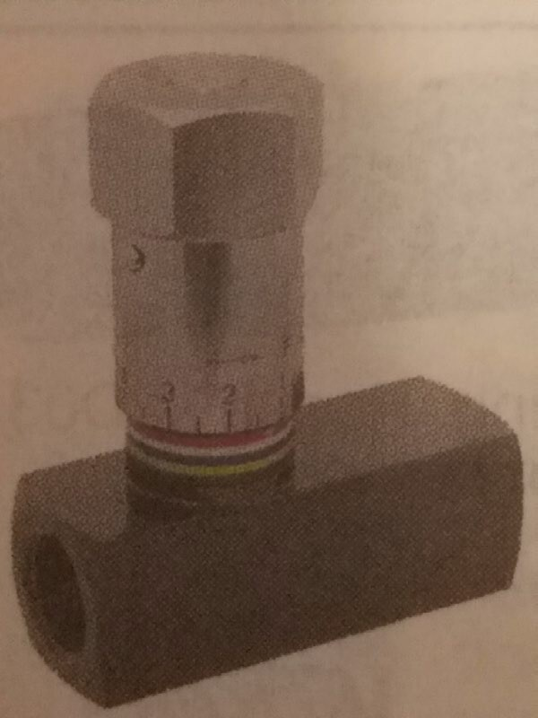
Two scissor lifts on a trailer to move a shed. This is the simplest circuit to work with my tow vehicle for lifting, leveling and lowering.

Vehicle



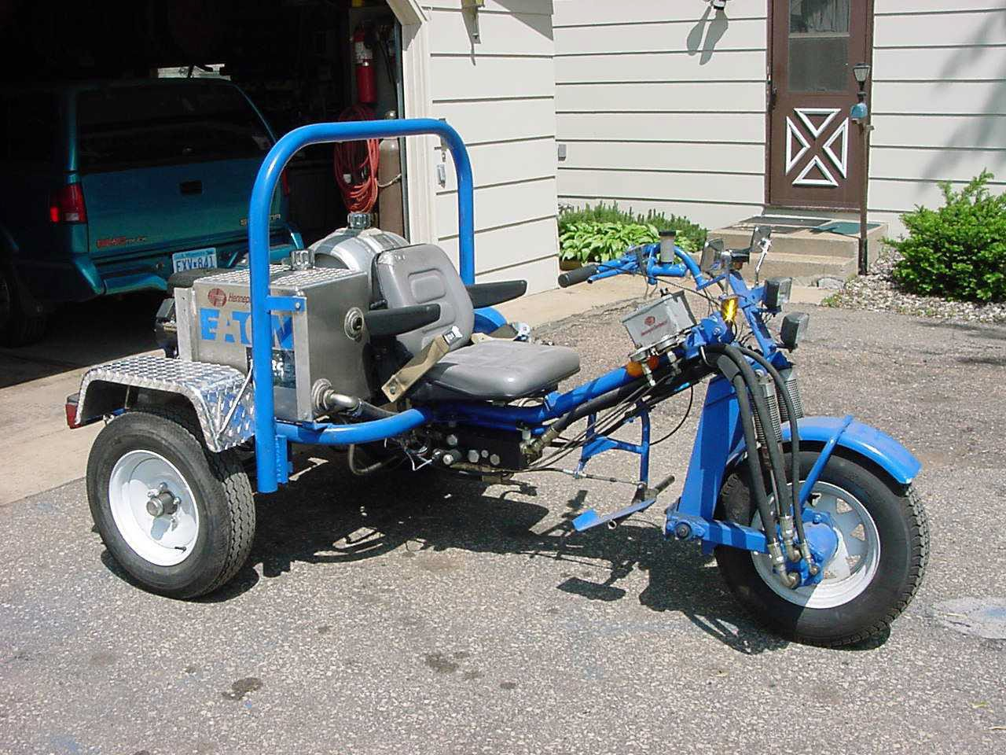

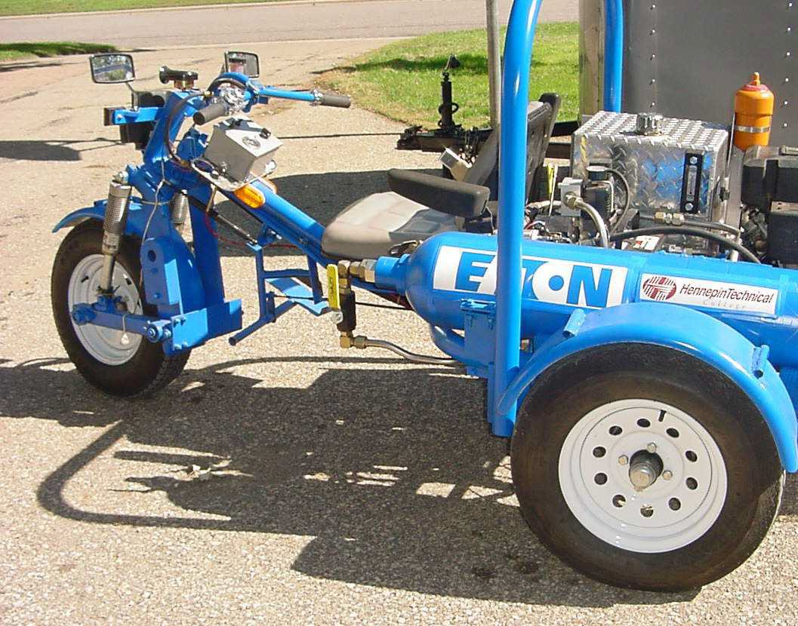
> 100 MPG



HAD ENOUGH?

- QUESTIONS?


