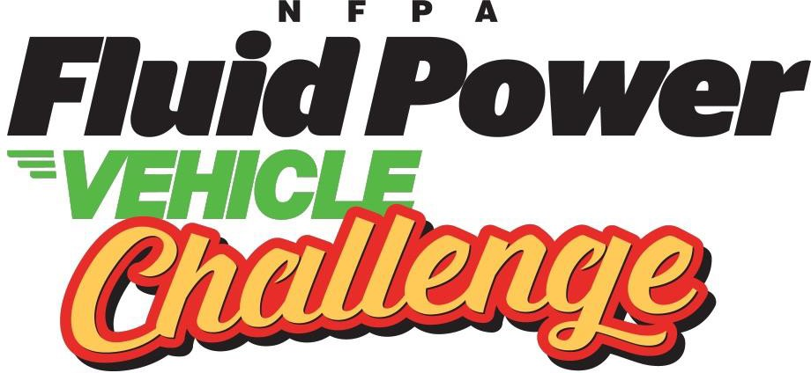

2023-24 NFPA Fluid Power Vehicle Challenge
FINAL COMPETITION - April 24-26, 2024
Danfoss Power Solutions | 2800 E 13th Street | Ames, Iowa 50010

VP of Workforce Programs Technical Liaison
Stephanie Scaccianoce Ernie Parker, Retired Faculty
National Fluid Power Association Hennepin Technical and Community College
sscaccianoce@nfpa.com ernieparker1@msn.com
(815) 274-4881 (612) 200-3359

Final Competition Host Workforce Program Manager
Dave Eggert Mary Pluta
Danfoss Power Solutions National Fluid Power Association
deggert@danfoss.com mpluta@nfpa.com
(515) 418-3005 (414) 736-3584

Workforce Program and Event Manager
Kyla Olson
National Fluid Power Association
kolson@nfpa.com
(414) 259-2025

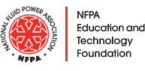

FINAL COMPETITION
The NFPA Fluid Power Vehicle Challenge final competition will be hosted by Danfoss Power Solutions, donor to the NFPA Foundation’s Pascal Society, from April 24-26, 2024.

“Danfoss is pleased to once again welcome students, advisors, and judges to our Application Development Center for the NFPA Fluid Power Vehicle Challenge. We look forward to seeing the results from the creativity, calculations, and practical hands-on problem-solving that each of the student teams has been challenged to deliver to this unique application of fluid power. I wish you all safe travels to Ames and best of luck in your preparations!”
-Jeff Herrin, SVP Research & Development
The final competition will be an exciting event where students, advisors, industry supporters, and other invited guests experience the final leg of this dynamic undergraduate engineering design challenge.
Students will present and demonstrate their designs, industry supporters will judge their work and winners will emerge.

The nature of the final competition is a three-day endeavor. Student teams travel to Danfoss in Ames, Iowa to assemble their vehicle on the first day. All program participants will attend a welcome dinner reception that evening. The race events are scheduled for the second day of the event.* A panel of industry supporters assesses the vehicles for their design concept, reliability, safety, durability, craftsmanship, and robustness. Immediately following the design review, the four competition events commence. These include the sprint race, efficiency race, endurance race, and regen race. Student teams and industry members are invited to an evening networking reception on the second day. On the event’s final day, team presentations describe the design phase, concepts, component identification, testing, analysis, and assembly of the vehicle. A panel of industry supporters evaluates these presentations, and scores are incorporated into a final team tally. Danfoss provides a networking lunch for all attendees after the presentation session blocks. All program participants are invited to an evening reception, dinner, and final awards ceremony.

*This schedule may be adapted in response to weather conditions.

IMPORTANT DATES and DEADLINES (see additional details below)
Registration by: March 1, 2024
Proof of working vehicle by: April 1, 2024
Hotel reservations by: April 17, 2024
Ship vehicle by: April 15, 2024 (Arrange shipping by April 10, 2024)
Final Presentation & All Mentor Summaries by: April 22, 2024
If driving, deliver vehicle by: April 24, 2024 between 12:00 - 4:00 PM
Travel Reimbursement and Award Delegation documentation by: May 26, 2024

Click Here For a Map of Important Event Locations

Contents
FINAL COMPETITION 2
FPVC Website 4
REGISTRATION 4
Travel and Other Expense Reimbursement 4
PROOF of WORKING VEHICLE & PHOTO 5
VEHICLE TRANSPORT LOGISTICS 5
DRIVE AND DELIVER 5
SHIPPING 5
MATERIALS, EQUIPMENT, AND SUPPLIES 6
WEIGHING VEHICLE 6
ARRIVAL 6
TUESDAY, APRIL 23rd 6
WEDNESDAY, APRIL 24th 6
THURSDAY, APRIL 25th 7
FRIDAY, APRIL 26th 7
ON-SITE PARKING 7
DRESS CODE 7
SAFETY 8
PRESENTATION & POSTER 8
EVENT RACES 8
JUDGING and MARSHALS PROTOCOLS 9
WI-FI ACCESS 9
HUMAN RESOURCES 9
GUESTS 9
RESTROOMS 9
NFPA FPVC POLICIES 10
DANFOSS POLICIES 10
FINAL THOUGHTS 10

This document is intended to provide more specific details related to the final competition event. Participants should carefully review the Overview, Rules and Awards document to ensure they understand program details and procedures.

FPVC Website
For the most up to date details and documentation, refer to the Vehicle Challenge website.

SOCIAL MEDIA HASHTAG
The Vehicle Challenge hashtag is #FPVC. Please use this on all of your social media posts about your project and the event. And don’t forget to take and share lots of photos! Show the world your vehicle, your team, and all your favorite parts of the Challenge (like your travel to Ames, the nightly events, and the Competition). Remember to tag the NFPA and Danfoss Power Solutions on your posts (see table below) and use the hashtags: #FPVC2024, #DanfossMoment2024.

 | Facebook | X (Twitter) | LinkedIn
NFPA | @FluidPowerChallenge | @TheNFPA | @TheNFPA
Danfoss Power Solutions | @Danfoss Power Solutions | @DanfossPower | @Danfoss Power Solutions

REGISTRATION
All general attendees including student teams, faculty advisors, industry supporters, judges, marshals and guests will register by March 1, 2024. Register here.

Advisors will be asked to:
- Submit the teams’ needs for hydraulic fluid and nitrogen at the competition.
- Indicate whether the team will be shipping or driving and delivering their competition bike to Danfoss.

Travel and Other Expense Reimbursement
For travel and qualifying expenses related to the final competition, NFPA will reimburse up to a total of $5,000 directly to universities for one faculty advisor and up to seven students, participating in the event. Advisors or university faculty will be required to submit the Travel Reimbursement Form in excel format and one PDF file of all receipts and supporting documents to NFPA Office Manager, Carrie Berger at cberger@nfpa.com. no later than May 26th. NFPA reserves the right to deny reimbursement if expenses are unrelated to the final competition or not a qualified expense. Travel reimbursement will be paid directly to universities, not to individuals, no exceptions will be made. Receipts are required for every expense item, no exceptions. If travel creates a personal or institutional financial hardship, please inform Mary.

Team Accommodations
Student teams and advisors are to make hotel reservations following these instructions:
Quality Inn & Suites 2601 East 13th Street Ames, IA 50010
Phone: 515-232-9260
Check in: 3:00 PM
Check out: 11:00 AM
Group Name: NFPA National Fluid Power ASSN $99.99 + tax
Cut-off Date: April 17, 2024
(If you do not book your room by this date, you will not get the reduced rate of $99).
Reserve using this link: https://www.choicehotels.com/reservations/groups/OE85E7

Qualifying Reimbursable Expenses:
- Team Accommodations at the hotel that NFPA designates.
- Team Transportation
  - Airfare (coach/economy flights only)
  - Auto rental
  - Trailer rental
  - Personal vehicle mileage
- Travel Related Expenses
  - Meals not provided by NFPA or Vehicle Challenge event host.
  - Taxi, Uber, Lyft, Tollways, Parking, etc.
  - Other qualifying expenses as determined by NFPA.

PROOF of WORKING VEHICLE & PHOTO
It is required that teams demonstrate your vehicle is in working condition by submitting a YouTube video to the website indicating your intent to participate in the final event. The footage must:
- Confirm that the vehicle is safe and operational with a team member riding it at least one-half of a block or better.
- Verify stored energy working off the accumulator.
- Confirm the use of pressure indicators and test point.
- Your proof of a working vehicle must be received by April 1. Teams can manage who can view content through privacy settings of YouTube videos. Learn how here. Teams are also required to submit one photo of only their vehicle for judges to refer to during the final competition. Submit your video here!

VEHICLE TRANSPORT LOGISTICS
There are two options for transport and delivery of the vehicles. 1) Drive and deliver to Danfoss, 2) Ship. Vehicles should be crated no matter which delivery method is chosen, although not required for drive and delivery if properly secured in a trailer. Be sure the crate is forklift compatible. Teams may build a crate from scratch or use a crate from a previous year. If shipping, release all oil pressure and lower the nitrogen pressure to 50 PSI. Do not empty the accumulator all the way and let air into it. Keep 50 PSI in the accumulator (plus or minus 25 PSI is okay but aim for 50 PSI). If not shipping, you may keep your accumulator charged.

DRIVE AND DELIVER
If you choose to drive and deliver your vehicle to Danfoss, be sure it is secure in every possible way during transport and delivery. The vehicle drop-off window is strictly Wednesday, April 24th, 12:00 PM to 4:00 PM. If for any reason teams suspect they will arrive later than 4:00 pm, they must contact Mary at mpluta@nfpa.com as soon as possible. If driving, Teams must bring environmentally friendly fluid from Lubrizol to Danfoss.

SHIPPING
If you choose to ship, each university will be asked for a contact name, phone number, pick- up / return address and any special instructions. Each team will be creating shipping labels and scheduling a pick-up for themselves. April 15th will be the pick-up day for teams that choose to ship their competition bikes. Arrange for shipping as soon as possible.
- Note: NFPA will not support expedited shipping. If the bike needs to be shipped back to your university by a certain date, the university will be responsible for this expense, and it will not be reimbursed. If you need to make these arrangements, contact Mary at mpluta@nfpa.com
- Teams that ship the vehicles will need to print the T-Force Bill of Lading Form from the Vehicle Challenge website and fill out these things on the Bill of Lading (BOL):
  - Date (top right)
  - Shipper (From) info: Full school address where crate will be picked up
  - Contact name and phone number
  - Check the lift gate box (so that a lift gate capable vehicle can come to pick up your crate).
- Next, Call T-Force Customer Service (PICK-UP SHOULD BE NO LATER THAN APRIL 15):
  - You will need the weight and dimensions of your crate (with pallet). When you have that, call TForce Freight at (800) 333-7400.
  - Pick Option #1 to schedule a pick up
  - You will be transferred to a live customer service representative who will ask the basic pick up and destination questions (location, liftgate, etc.).
  - Make sure you ask the representative for the class code (this will prompt them to get the crate dimensions and weight (with pallet) from you. They will then provide the class code.
  - Make sure to fill-in the CLASS Code and Weight that T-Force gives you near the bottom of the BOL (this is based off your package specifics)
  - Print off BOL for the T-Force Pickup and attach to crate
  - Email Mary at mpluta@nfpa.com with your tracking or BOL number
  - Crates should be labeled “FLUID POWER VEHICLE CHALLENGE ATTN: ADC”
  - Environmentally friendly fluids from Lubrizol and nitrogen will be provided on-site. Teams do not need to ship fluid or nitrogen.

MATERIALS, EQUIPMENT, AND SUPPLIES
It is required that you bring your own tools, extra equipment or supplies and environmentally friendly fluid from Lubrizol (if driving). Environmentally friendly fluids from Lubrizol and nitrogen will be provided on-site. Teams do not need to ship nitrogen. Depending on how you travel, decide which is a better method of transporting extra tools, equipment, and supplies. Packing the tools in the vehicle crate is a good option; be sure to properly secure any additional materials. Bring all extra items to the Danfoss site as participants will not be allowed to leave the facility to collect supplies left behind.

WEIGHING VEHICLE
Your vehicle will be weighed using an overhead scale, like this one. Please identify multiple strap attachment points for stability before coming to the competition. Keep in mind that the vehicle must remain level during weigh-in without tipping over. Wheels are not suggested hanging points.

ARRIVAL

TUESDAY, APRIL 23rd
Tuesday is considered a travel day as needed and will qualify as a reimbursable expense. Please see the details for hotel accommodation above. Check in is at 3:00 PM. Note: All teams are expected to arrive at Danfoss during the 12-4 drop off window on Wednesday, April 24th to conduct their vehicle assembly and pre-race system inspection. Please contact Mary Pluta if arriving in time for vehicle assembly on Wednesday presents a challenge for your team.

WEDNESDAY, APRIL 24th
STUDENT TEAMS:
Vehicle drop-off and safety check will be from 12 pm to 4 pm. Teams will not have access to the facility before 12:00 PM. See instructions above. There will be a welcome reception at 6:00 PM with dinner and beverages for participants held at Prairie Moon Winery. The address is: Prairie Moon Winery: 3801 W 190th St, Ames, IA 50014. You are responsible for your own transportation.

JUDGES & VOLUNTEERS:
If arriving on Wednesday, April 24th, judges, and volunteers are welcome to join student teams and advisors at the welcome reception for dinner and beverages at 6 pm.

THURSDAY, APRIL 25th
STUDENT TEAMS:
Upon arrival, student teams and advisors will collect additional registration materials and personal protective equipment. The teams will be split into groups and escorted to the ADC garage for vehicle assembly, design review and races. There will be a networking reception with dinner and beverages at 6:30 PM at Gatherings in Nevada, IA. The address is 1024 6th Street, Nevada, IA 50201.

INDUSTRY REPRESENTATIVES:
If arriving on Thursday, April 25th, judges should plan to be at the Danfoss campus by 8:30 am to check- in at the security desk and collect badges. Upon arrival, judges and volunteers will be escorted to the Danfoss Lower Level Conference Center for a safety and orientation session. Vehicle Design Review will begin at 9:30 AM. Races will be conducted in the afternoon.

EVERYONE:
A networking dinner will be held at 6:30 pm at Gatherings in Nevada. The address is 1024 6th Street in Nevada, IA 50201. You are responsible for your own transportation.

FRIDAY, APRIL 26th
Teams and judges will arrive at Danfoss at 7:30 AM for Final Presentations and to disassemble their vehicle and prepare it for transport. If student teams design a project poster, it can be posted after the first session for other guests to view. Judges will attend a final meeting after the presentations have concluded. The award ceremony and final networking dinner will begin at 6:00 PM in the Garden Room at the Reiman Gardens at Iowa State University. It is located at the intersection of University Boulevard and South 16th Street Ames. The address is 1407 University Blvd, Ames, IA 50011. You are responsible for your own transportation.

ON-SITE PARKING
Danfoss is conveniently located near the intersection of Interstate 35 and Highway 30. Complimentary parking is available on-site. Watch for signs directing you to the Vehicle Challenge parking area. If needed, there will be parking for trailers by the Danfoss ADC garage or another designated spot on campus.

DRESS CODE
The dress code for non-competition events is business casual. Explicitly, the dress code is less formal than traditional business wear, but it is intended to give a professional and business-like impression. The dress code for competition events is informal and casual, however, no shorts or skirts are permitted for safety reasons. Remember, there will be long periods of time when teams are outside, dress accordingly and plan for the weather. The wind can be very strong on the competition track. Students are encouraged to wear university-branded shirts to identify different teams during the event. NFPA issues stipends can be used for this purpose.

SAFETY
During the competition events and/or tours, personal protective equipment is required:
- Footwear: Participants are to wear reasonable footwear for the event. No open-toed shoes, sandals, heels, or thick-soled shoes. Steel toe shoes are recommended. NFPA stipend funds can be used to purchase these if you do not own them.
- Eyewear: Safety glasses (with side shields) will be required. Either bring your own or Danfoss will provide.
- Riders must bring and securely fasten a CPSC-approved bike or motorcycle helmet during the competition events. See photos below.
- Attire to avoid: shorts, loose-fitting clothing like dresses/skirts, loose necklaces/bracelets.
- Long hair must be tied back.

Note: CPSC Approved Helmets have this sticker. Photo Credit: Beactivedecatur.com
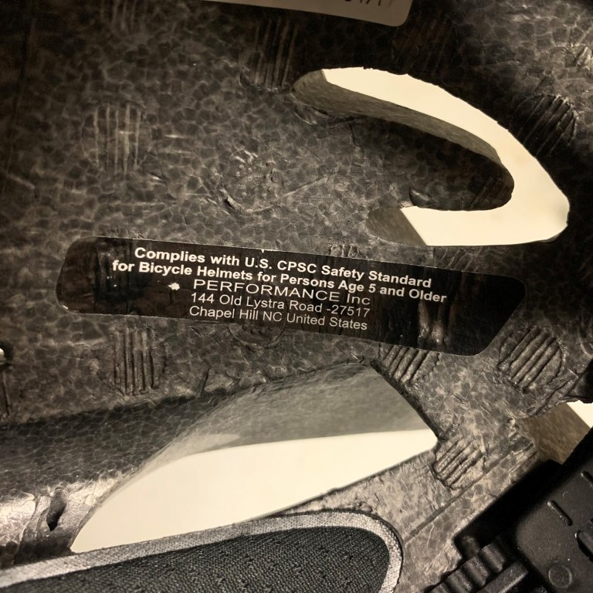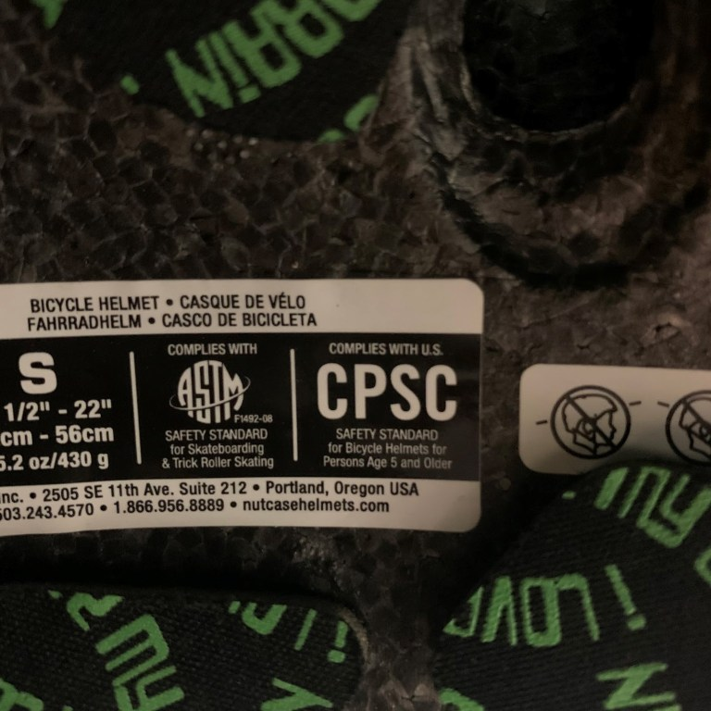

PRESENTATION & POSTER
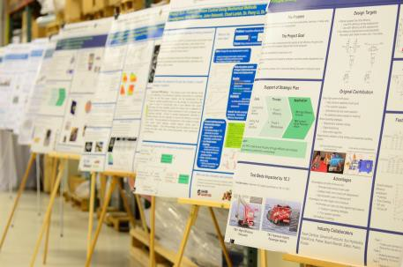
The final presentation (in PPT) is due no later than Monday, April 22nd by 11 AM CDT on the Vehicle Challenge website.

Student teams are invited to create, print, and share a project poster to be displayed in the Danfoss Conference Center for general attendees. It is not a requirement to create a project poster, however, it would provide an excellent visual for guests in advance of the final presentations and competition. A project poster example is shown on the right. Please notify Mary at mpluta@nfpa.com by Monday, April 22nd if you are bringing a poster.

EVENT RACES
The event races will demonstrate the various elements of the vehicle design. For additional information, please see the Track Map with elevations.

JUDGING and MARSHALS PROTOCOLS
The final competition relies on the volunteer commitment by many industry representatives.

Judging Committee
A team of industry judges is responsible for assessing the vehicle on-site and the documentation in advance. The nature of the assessment is described in the FPVC Assessment Rubric.

Two responsibilities that we ask Judges to cover are:
Marshals
A team of marshals will be responsible for ensuring teams are operating in a safe and sportsmanlike way during the entire event, and during the four competitions (sprint race, efficiency race, endurance race, and regen race). Marshals may choose to engage directly with the competitors or observe from a distance.

Marshals may walk, jog, run, or cycle alongside the vehicle during a competition event. Marshals will provide input to the judging committee on the vehicle performance and teamwork of the event participants.

Timekeepers
A small team of timekeepers will be responsible for the clock, recording time, and submitting data to the Program Manager.

AWARDS
The Judging Committee determines final award winners based on a number of factors, including the overall assessment of (1) the Design and Specification Midway Review, (2) the competition results, (3) final presentations and (4) Interaction with Industry Mentors. The decisions of the judging panel are final.

WI-FI ACCESS
There are various Danfoss building locations that have poor cellular service for particular carriers. Danfoss will provide one guest Wi-Fi access per student team and for all industry representatives. Name and email will be provided to Danfoss for access. Cellular service is sufficient outside of the building and on the Danfoss Test Track.

HUMAN RESOURCES
Danfoss ambassadors and talent scouts may be available during lunches as an opportunity for students to network with fellow engineers and ask questions in an informal setting. Please bring a printed copy of your resume if you are still looking for a job.

GUESTS
No guests are permitted at the competition.

RESTROOMS
Please avoid touring the facility in search of restrooms. Restrooms that are to be used by Fluid Power Vehicle Challenge participants will be clearly marked with signage. There will be portable restrooms for use during the outside competition events.

NFPA FPVC POLICIES
During the final event, any participant demonstrating unsportsmanlike or unsafe conduct will be disqualified from the Challenge and forfeit any and all awards. Driving under the influence is automatic elimination. The same rules apply as driving a motor vehicle on the highway. It is expected all participants honor the Host Site’s local zero-tolerance policies.

DANFOSS POLICIES
Danfoss Power Solutions has a zero-tolerance weapon, alcohol, and tobacco-free campus policy. E-cigarettes and vaping devices are also prohibited. Participants are subject to elimination and being removed from campus for violating these stated policies.

FINAL THOUGHTS
Let’s make a great impression on Danfoss and the other industry representatives. Both personally, and
professionally, you can never have too many friends.

