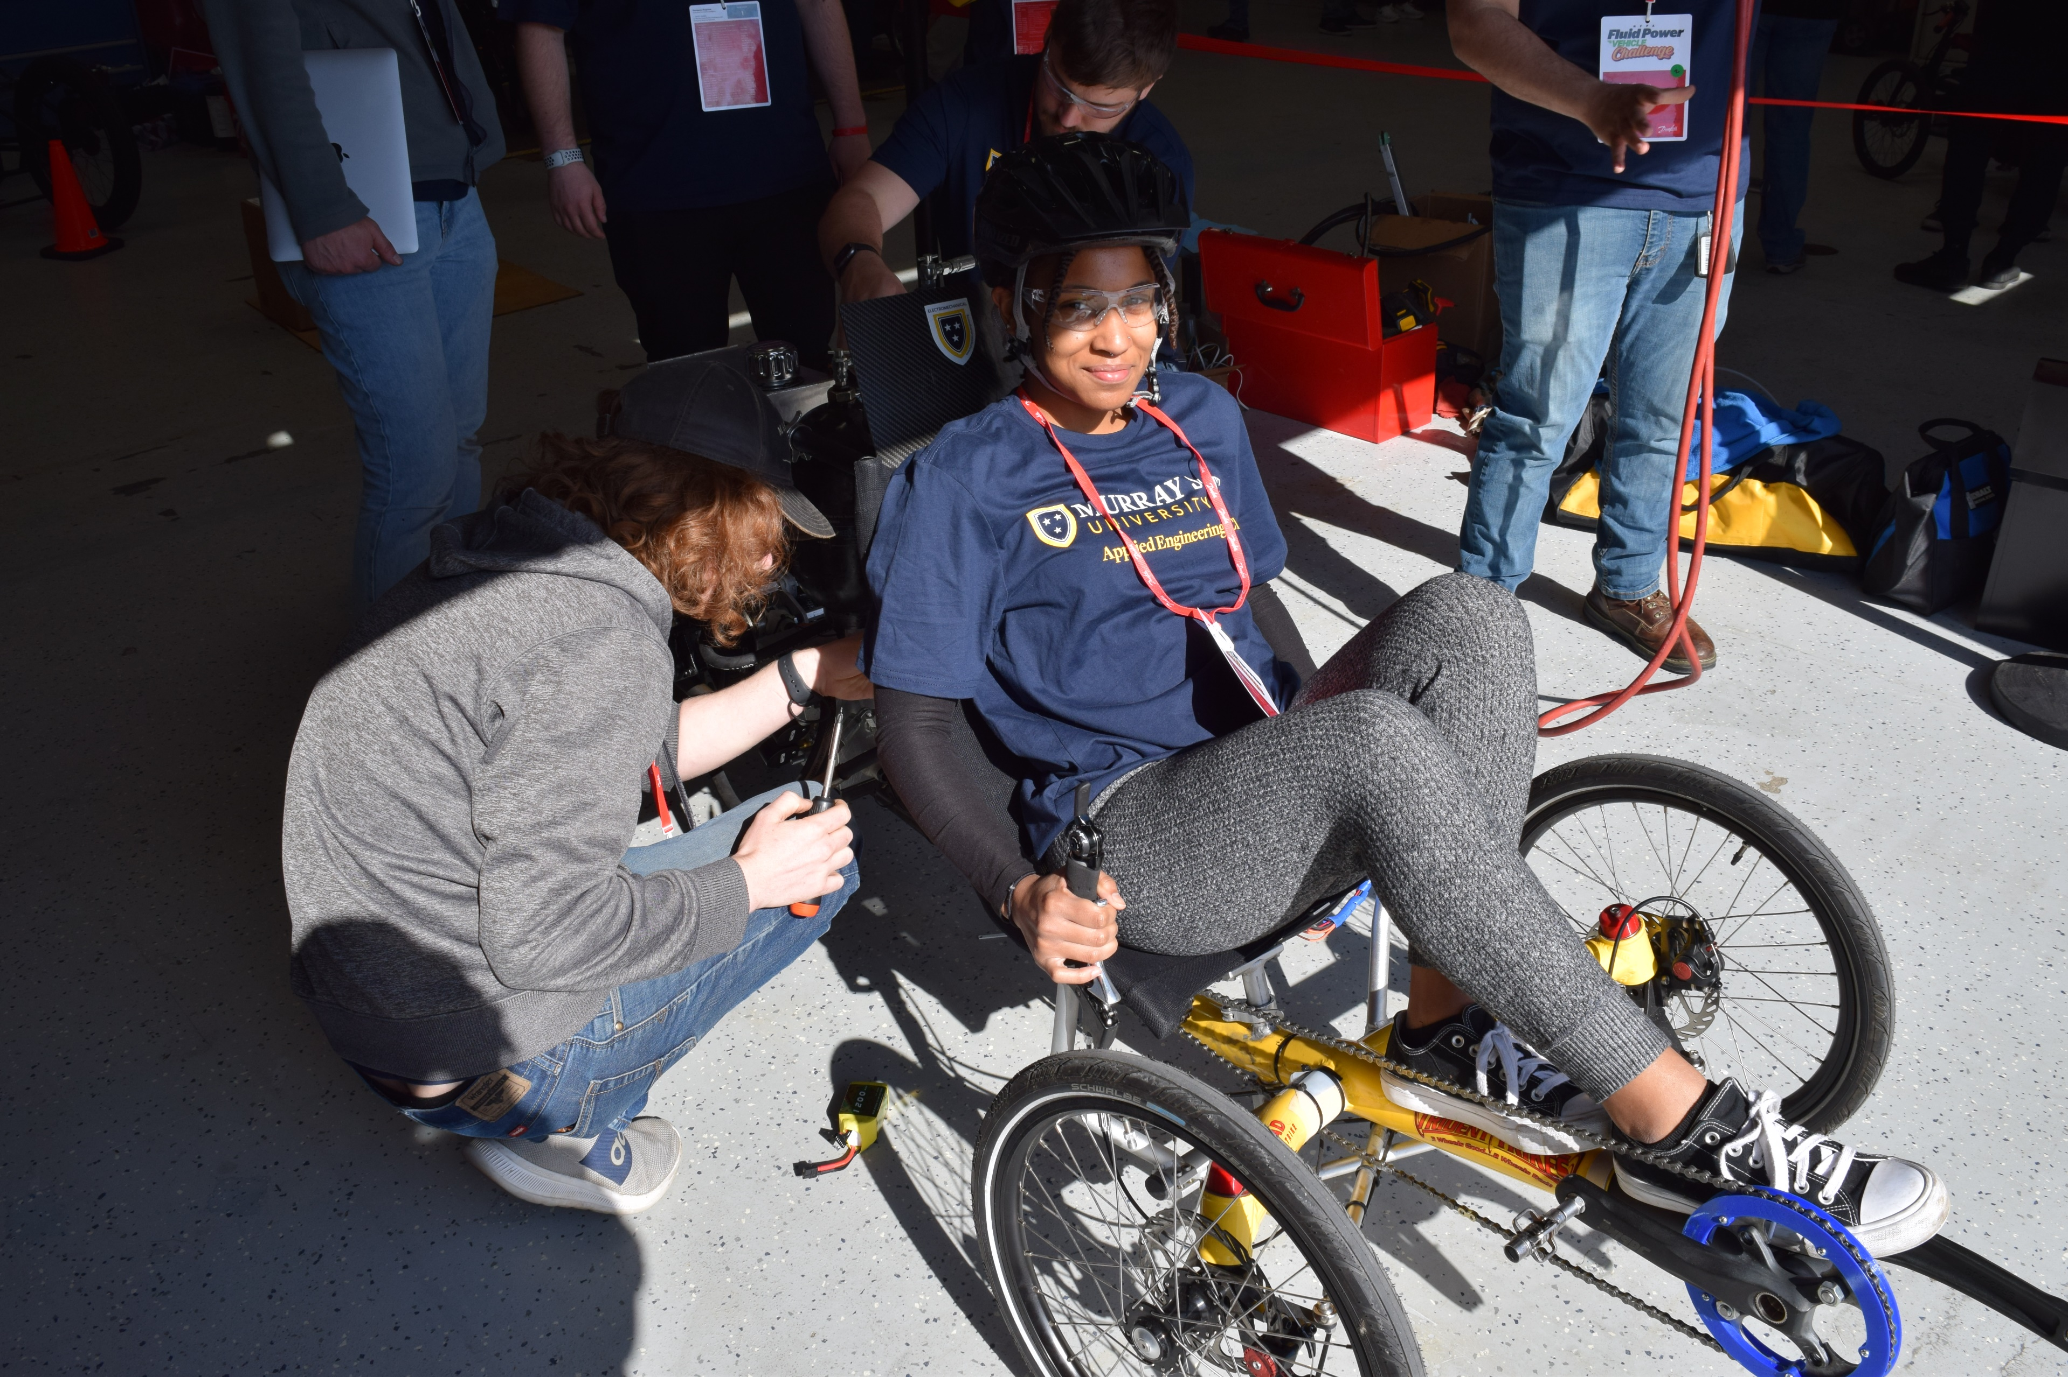
Project Proposal
Email: mpluta@nfpa.com
Phone: 414-778-3359
Program Manager
Mary Pluta

National Fluid Power Association Association

Program Year 2023-24

Objectives

- Stimulate education in fluid power components, circuits, and systems, incorporating them into a systems engineering experience.
- Provide students with experience in real world engineering under a strict timeline of designing, simulating, ordering, building, testing, and demonstrating their designs.
- Stimulate innovative thinking for designing and testing potential new fluid power technologies or concepts integrated into a vehicle platform.
- Provide an industry recruitment opportunity for high potential engineering seniors by engaging directly with practitioners in the fluid power industry.

Overview and Background

The NFPA Vehicle Challenge is based on the Chainless Challenge program, pioneered and managed by Parker Hannifin from 2004 through 2016. The first program under the Vehicle Challenge name was held in 2017.

The Vehicle Challenge encourages universities to participate in the context of their senior capstone design courses, but student teams in other configurations are welcome. Either way, students are required to design and build the drive system for their vehicles, as well as participate in the Final Competition Event. They can utilize either off-the-shelf components provided by the program’s official parts and fluids suppliers, from other suppliers and resources, or design their own. The Final Competition Event includes judging criteria for a straight sprint race, an efficiency race, a regen race and an endurance race. In addition, teams will present their design process and decisions, and demonstrate the safe function of their vehicles. The Event will be conducted over a two-day period at a location hosted by one of the donors to the NFPA Education and Technology Foundation. Norgren, a part of IMI plc, will host one event at their facility in Littleton, Colorado and Danfoss Power Solutions will host the other at their facility in Ames, Iowa. Travel funds are provided by the program to offset the transportation and accommodations costs of the participants. Cash awards are given to the winning teams in several specified categories.

Click here to view a two-minute video of final competition!

Design Team

One team per university will be funded through the program. Team members may have participated in previous years.
- One faculty advisor and up to seven students will be eligible to receive travel funds to the Final Competition Event.

Resources

Personnel
Two NFPA program staff, one Technical Liaison, at least one industry mentor assigned to each team and a panel of judges from NFPA member companies will be available to guide teams. Last year, representatives from twenty-seven companies participated in the mentoring program or served as competition judges.

In support of the Student Team activities, three separate stipends of $1,000 each will be disbursed upon completion of:
- Kick-Off Webinar & Registration
- Design and Specification Midway Review
- Final Presentation
Teams that participate for the first time receive a $1,500 stipend for the Kick-off Webinar, only. These stipends are restricted for use by current and future team participants for supplies and activities directly related to the NFPA Fluid Power Vehicle Challenge. The Final Presentation stipend payment may be lumped into any prize awards issued to the university at the Final Competition.

Travel and Other Expense Reimbursement
For travel and qualifying expenses related to the final competition event, NFPA will reimburse up to a total of $5,000 directly to universities for one faculty advisor and up to seven students, participating in the final competition event.

Qualifying Reimbursable Expenses:
- Team Accommodations at the hotel that NFPA designates.
- Team Transportation
  - Airfare (coach/ economy flights only)
  - Auto rental
  - Trailer rental
  - Vehicle shipment to and from the final competition (as needed)
  - Personal vehicle mileage
- Travel Related Expenses
  - Meals not provided by NFPA or Vehicle Challenge event host.
  - Taxi, Uber, Lyft, Tollways, Parking, etc.
  - Other qualifying expenses as determined by NFPA.

