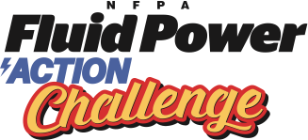
Challenge Rubric

SAFETY IS OUR NUMBER ONE CONCERN

 | Criteria | Points
Portfolio Rubric Contents to include:  Total possible points - 50 | - Quality of portfolio’s presentation including title and index pages  - A detailed outline of each team member’s participation in the production of the portfolio and planned production of the device  - At least 3 illustrations of initial design concepts of possible device  - Materials used to build prototype from the Workshop Kit including dimensions  - Description of the use of the principles of a strong and stable structure  - Rationale used to decide on the type of fluid power used and where to place the piston-syringes  - Isometric drawing of a portion of the prototype  - Orthographic drawings showing dimensions and construction notes  - List of alternatives materials that would have been useful with reasons why  - Evaluation of prototype including the conclusions from making it | - 0-5  - 0-5  - 0-5  - 0-5  - 0-5  - 0-5  - 0-5  - 0-5  - 0-5  - 0-5
Work Habits  Total possible points - 10 | - Members of the group work independently and cooperatively and in an organized way  - Members of the group demonstrate safe working practices | - 0-5  - 0-5
Interview  Questions  Total possible points - 20 | - What alternative designs did you look at before selecting the design you are building today?  - Why did you select this design to use for the Challenge?  - What did you find most difficult with the project overall?  - How did you decide who on your team would be responsible for which parts of the project? | • 4 X 5  = 20
Design, construction and operation of device  Total possible points - 10 | - The device uses materials effectively and is well constructed with parts securely attached  - The device itself operates efficiently and is operated in an organized way | - 1-5  - 1-5
Challenge | Number of points scored by moving objects successfully in 2 minutes | # points

