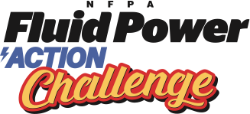
Sample Email
To Teachers Once Teams are Signed Up
Coordinators should customize

Subject Line: NFPA Fluid Power Action Challenge – Student Forms & Team Registration

Dear Challenge teams,

Thank you for signing up for the NFPA Fluid Power Action Challenge scheduled for <insert date> and <insert date> at <insert location>.

Attached are four forms for the event:

1. Challenge agenda/schedule
2. Rules for Challenge
3. Team Registration form (one per team)
4. Student Consent form (one per student)

Please complete and return the Team Registration and Student Consent forms to my attention no later than <insert deadline date>.

Also, it is a good time to visit and “Like” the NFPA Fluid Power Challenge Facebook page and use this channel to post any pictures and anecdotes from your students as the Challenge activities begin. https://www.facebook.com/FluidPowerChallenge/.

Let me know if you have any questions or require further information. We look forward to seeing you at the Challenge!

