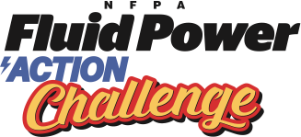
Teacher Feedback Form

School & District:
Teacher’s Name & Class Name:

Thank you for taking part in the NFPA Fluid Power Action Challenge. Please help us make the next event even better by providing feedback about your experience.

Have you had a team(s) compete in the Action Challenge before? Circle one: Yes No

Please rate the following criteria: (Enter E: Excellent; VG: Very Good; G: Good; F: Fair; P: Poor)
Criteria | Rating (enter E, VG, G, F or P) | Comments

Overall Experience
Pre-challenge workshop
Appropriateness of the task
Curriculum relevance

- The best thing from the overall experience was….

- Is there anything you would like to see changed?

- How does your team meet during the Challenge preparation time? (Cirlce one)
  - As part of an after-school program
  - After school as needed
  - During School

- Was your team successful in building a completed machine? (Circle one)
  - Yes and it was functional
  - Yes but it did not function
  - No (please let us know what the obstacles were)

- Do you have any suggestions to help teams be more successful on Challenge Day?

