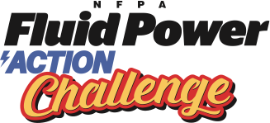
Photo/Video Consent Form

Photo/Video Consent Form

I, __________________________________________________, hereby consent to my child/myself
(Name of Parent /Guardian if Student is a minor-Under 18 Years of Age/Adult

________________________________________ being filmed, audiotaped, videotaped, quoted and/or
(Name of Student)
photographed by the media (print and broadcast), and employees, agents, or servants of <insert school name> on <insert date> and <insert date> at the NFPA Fluid Power Action Challenge being held at <insert school name>.

________________________________________________________________________________________________________________________________
(Signature of Parent/Guardian/Adult) (Date)

