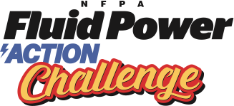
Sample Email
To Local Companies Asking for Support
Coordinators should customize

Dear ___________:

I am pleased to announce that <insert your organization name> is planning to hold an NFPA Fluid Power Action Challenge on the following dates:

Workshop day: <insert date> Challenge day: <insert date>

NFPA Fluid Power Action Challenge is a skills based competition for eighth grade students. The program challenges the students to solve a real life engineering problem using fluid power (hydraulics and pneumatics).

The event includes a Workshop Day where teams come together to learn about fluid power, build a pneumatic lifter and receive their challenge kits. Teams then take their kits (including tools and supplies), back to school to work on solving the challenge problem, developing a portfolio, and then building their prototype.

On the Challenge Day, the teams come together again to re-build their fluid power mechanisms and compete in a timed competition.

More information can be found at https://nfpahub.com/fpc/action-challenge/

The Challenge is an amazing event that truly gets students excited, teaches team building, problem-solving, time management and also introduces careers in fluid power that can build a skilled workforce in our community.

Would your company consider sponsoring the event? Attached is a form that you can use to help support the Challenge. We thank you for any support you can give.

We would love to have you attend the Challenge! Please let me know if you have any questions or need further information. We appreciate your support!

